**Calendar commands:-**

1. cal(to show current month with date):-

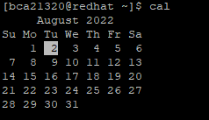

2. cal -1 (to show current month ):-

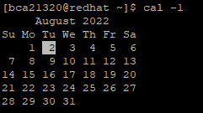

3. cal -3 ( to show 3 months cal. ):-

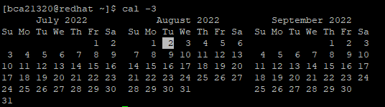

4. cal–s ( to show Sunday as starting day):-

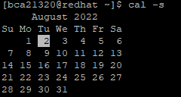

5. cal –m ( to start cal. With Monday ):-

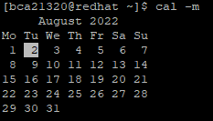

6. cal –y ( to show yearly cal. ):-

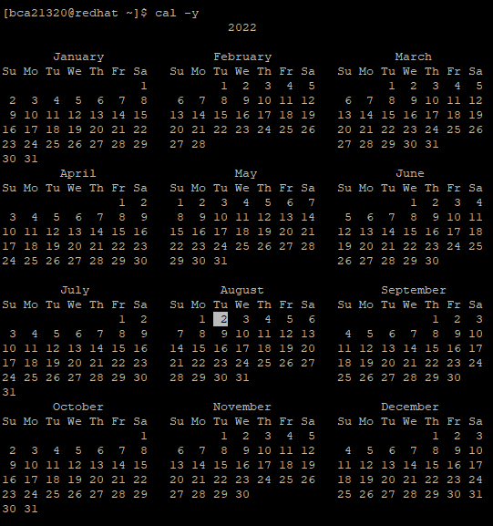

7. cal –j ( to show current day of a year ):-

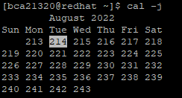

8. cal ( enter a specific year ):-

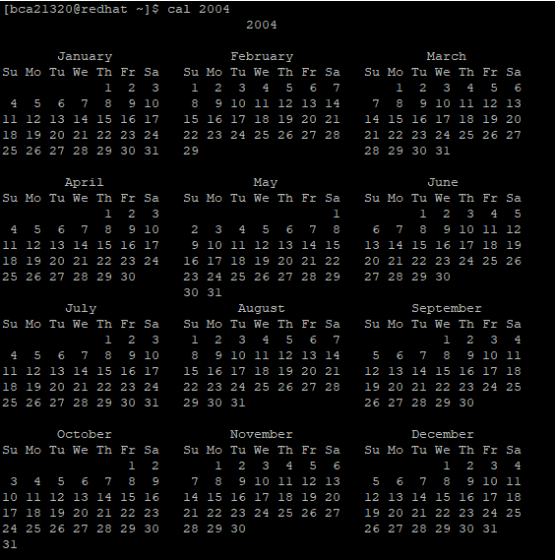

9. cal(enter a specific date):-

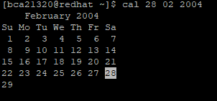

10. cal –y –j ( to show julian dates ) :-

